We’re finally rebuilding the WBEZ App, with our first release scheduled for mid-November. It will be the most significant update to the WBEZ app since 2016. This effort aligns with our 3-year strategic plan initiative to achieve 100,000 weekly app users in 3 years.

The current app’s audience is among the most loyal and engaged groups on any channels where users find us. The 20,000 weekly app users come to it on more than 3.5 occasions per week, with an average session duration exceeding 90 minutes.

In FY22 our goals are 3-fold:

* To build a stable foundation for continuous app development, so we can quickly add and iterate on new features in collaboration with the rest of CPM.
* To address lingering performance and reliability issues with the current WBEZ app, particularly on Android devices
* To grow the audience to 32,000 weekly users, a 50% increase.

The new app, which will be released as version 9, improves upon, expands, and stabilizes the most popular listening functions of the current app, and builds a foundation for continuous iteration of new features. It uses the React Native framework for app development, which allows us to develop the Android and iPhone versions in parity, with one codebase. Users will experience it as an update to their existing apps but be greeted with a whole new look and feel. Version 9 will include the following changes:

## HLS Streaming and Rewind

The most significant update is the replacement of the Replayer with a true DVR-like Rewind. Users will be able to rewind back in any increments within the hour that they’re listening. So if you missed the beginning of a segment and want to start it over, you can do that easily with a few taps.

All live broadcast and rewind playback will be supported by HLS streaming protocol rather than traditional AAC and MP3 formats. It holds a buffer going back 7 days worth of audio for the user to replay. HLS streaming technology underpins our current and future plans for making the listening experience more accessible and informed and offering new pathways for users to hear our best work. We’ve been working closely with StreamGuys to make use of their rewind technology and we are very excited to bring it to our users.

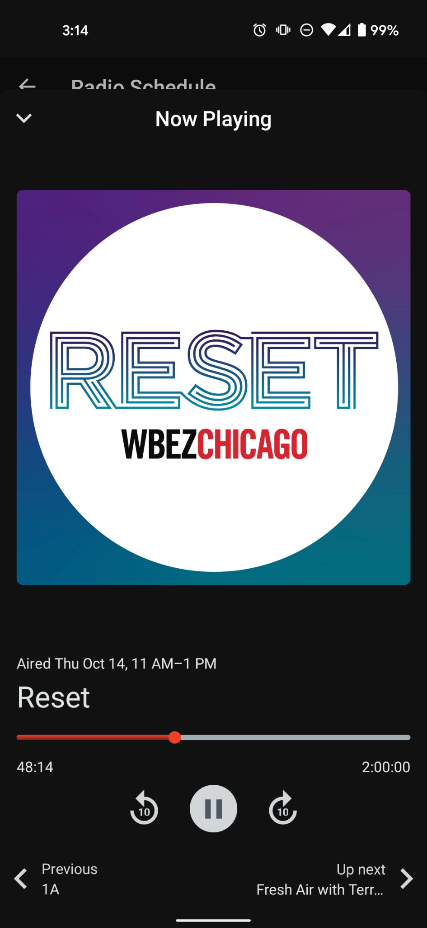

## Browse Screen

Beyond live and DVR listening, version 9 offers a Browse experience with several new pathways to listen. Users can play selected segments from the broadcast, with a feature we’re calling “Recent Highlights” (working title). Tapping one of these takes you to that precise moment in the broadcast when the selected piece aired. So you can jump right into a feature or two-way from the newsroom, a Reset segment, or NPR stories. These will be curated throughout the day in our CMS, so the latest items from today’s broadcast will always be available. The goal of Recent Highlights is to help listeners find interesting stories they might have missed.

Users can also play the latest newscast from WBEZ or NPR with one tap in the “Latest News Now” section. Given that some of our most important reporting is often in these newscasts, we wanted to allow for quick access to the app.

A single “featured” audio item will display prominently in the browse screen to promote anything we want, from a podcast episode to a news feature, to a doc. In collaboration with our broadcast and marketing teams, we will be coordinating our on-air messaging to align with app curation, so we can consistently drive users to the app to hear the latest Motive episode or the full reporting on a given story.

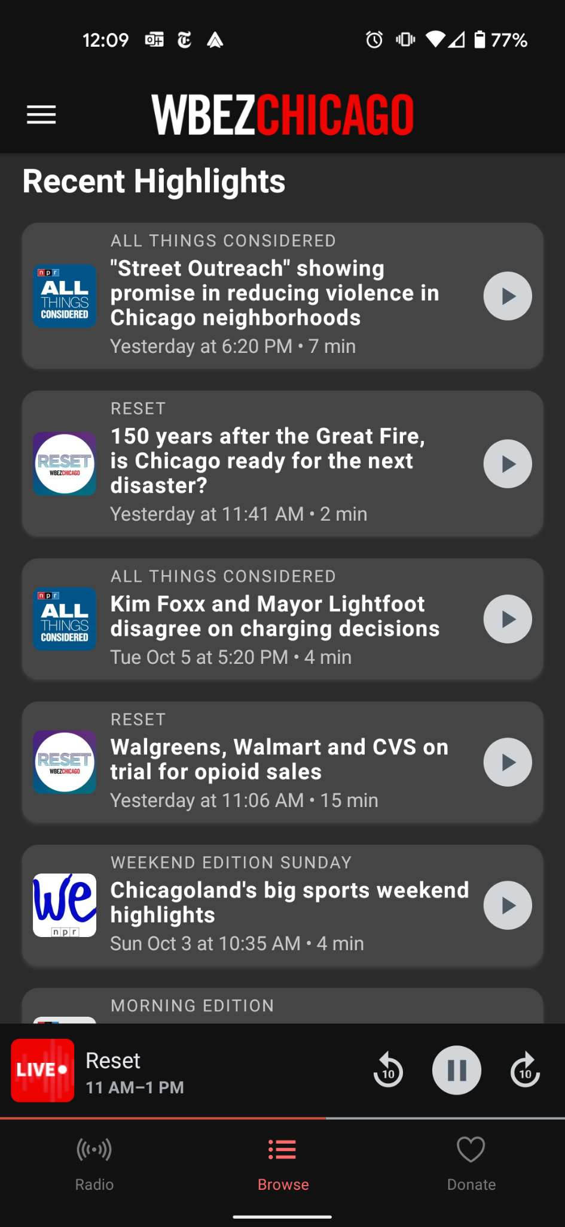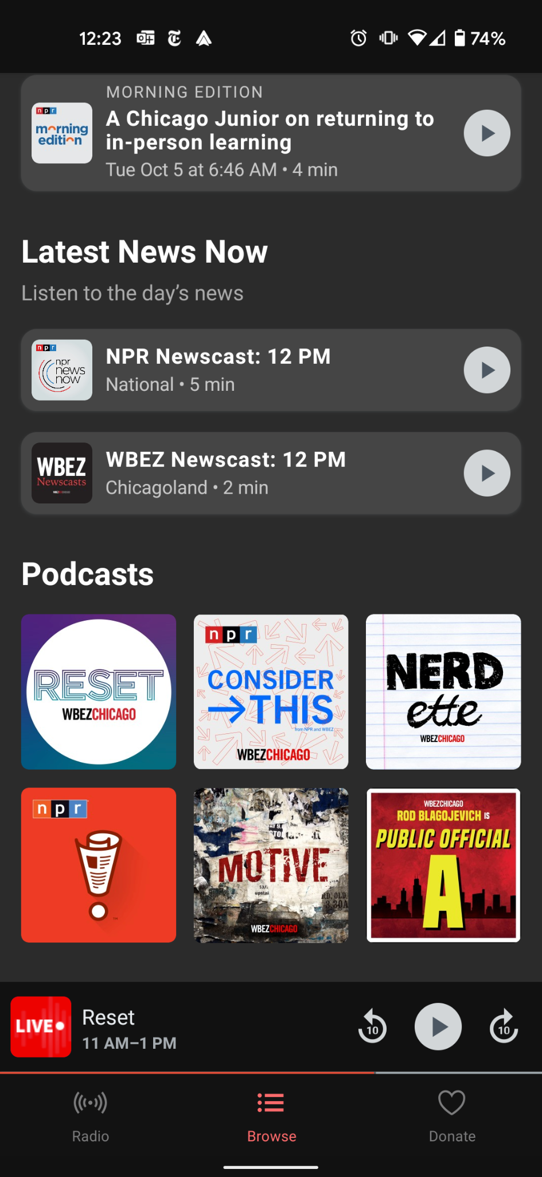

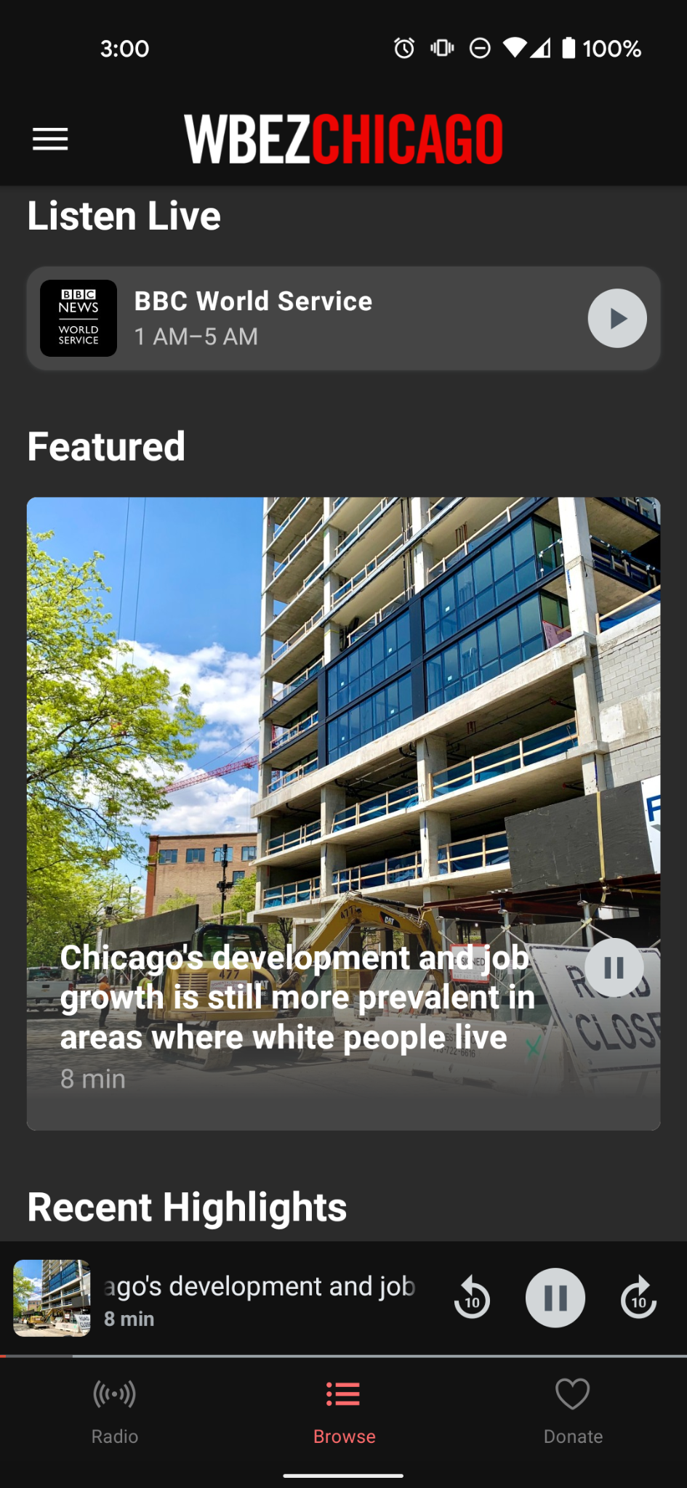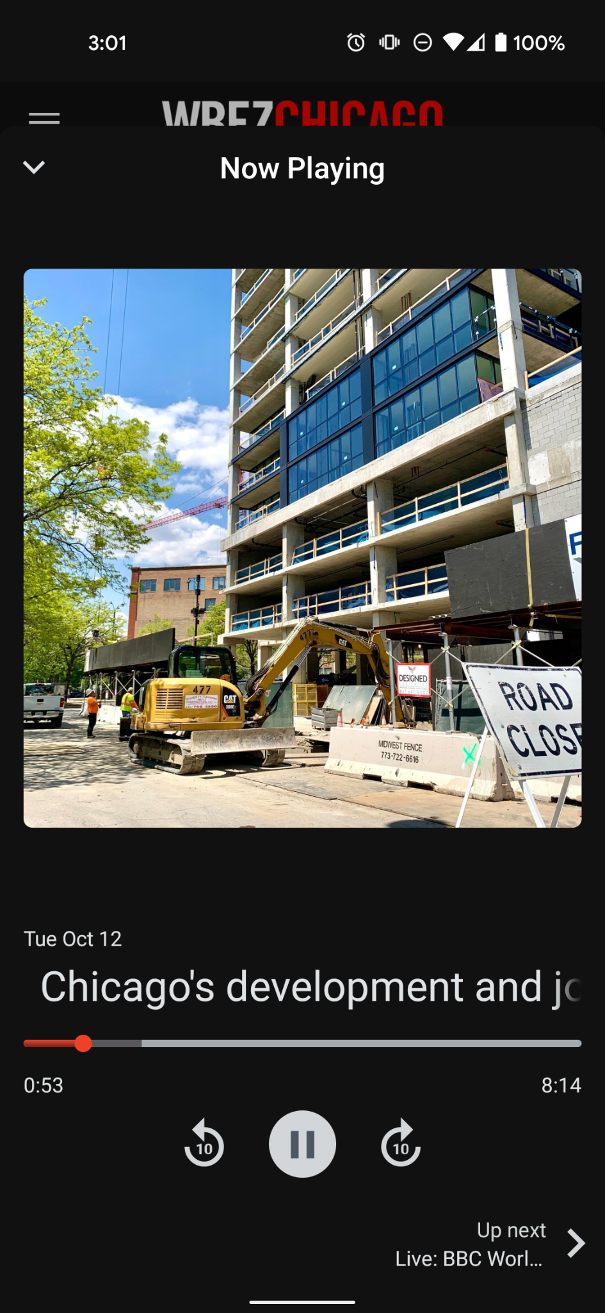

## Improving upon Existing Features

Version 9 will also feature our radio schedule in multiple browsable layouts and our podcast catalog. The podcasts will be condensed down to only our properties, and browsing episodes will be easier than before.

We have also overhauled how ads are delivered in the app. No longer will streamers be interrupted with another preroll when their signal drops momentarily. The app will dictate when users are eligible for our preroll sponsored ads, and we will have full control to manipulate those rules on the fly. We believe this will ultimately deliver a better experience for our users and offer a more attractive premium sponsorship opportunity.

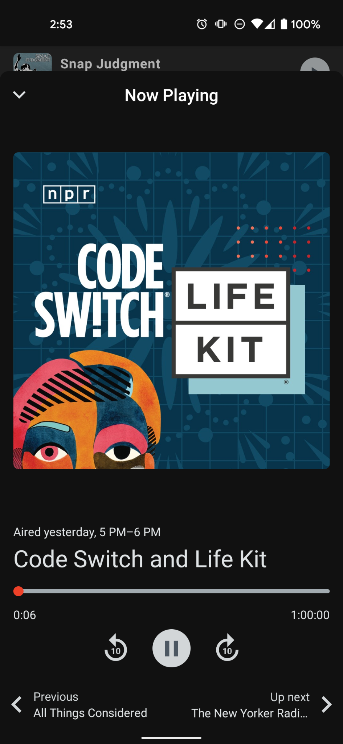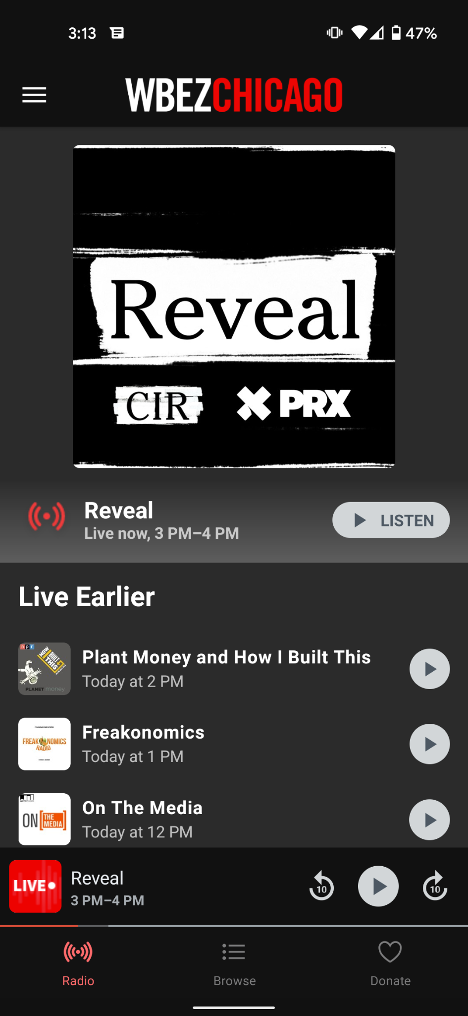

Timeline and Testing

The team led by Shira Gersten, Patrick Judge, Anna Gingle, Mi Tian, Oliver Holmberg, J. Kyle White-Sullivan has been working very hard to bring this full overhaul of the WBEZ app to life since August. We are marching toward a mid-November release of the app, targeting 11/9 for our submission to the app stores and a public release in the days following.

Although we have plenty of tweaks and polish left to do, we are pleased to have a near-code complete version available with almost 4 remaining weeks until our planned launch. Starting this week, Shira will be recruiting users to test a beta of the app, going through specific use cases to help us find any bugs we need to address before launch. If you have the time and interest, we would love to get your help!